**AWS EBS I/O 特性和监控**



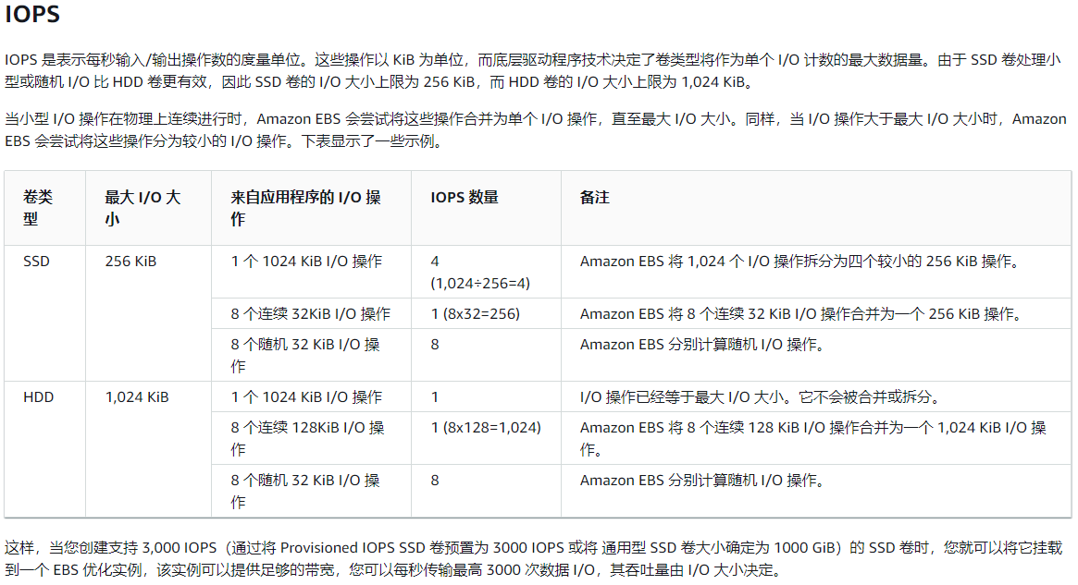

FROM: https://docs.aws.amazon.com/zh_cn/AWSEC2/latest/UserGuide/ebs-io-characteristics.html

**AWS gp3卷性能**

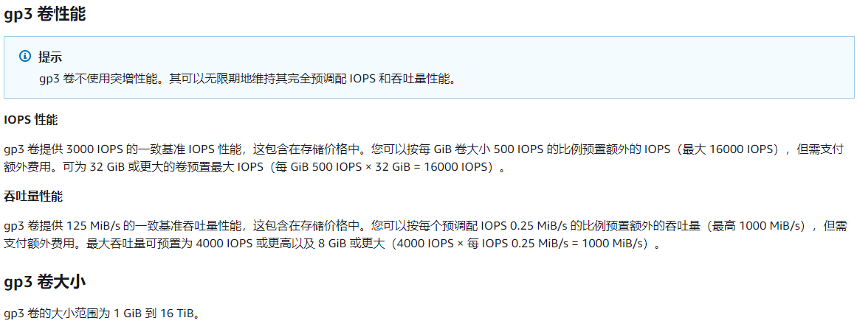

From: https://docs.aws.amazon.com/zh_cn/AWSEC2/latest/UserGuide/general-purpose.html

**预调配 IOPS SSD（io1 和 io2）卷**

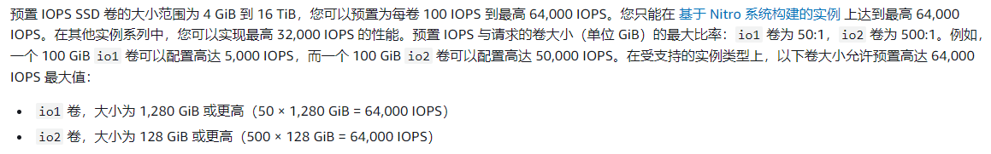

From: https://docs.aws.amazon.com/zh_cn/AWSEC2/latest/UserGuide/provisioned-iops.html

**Amazon EBS 定价**

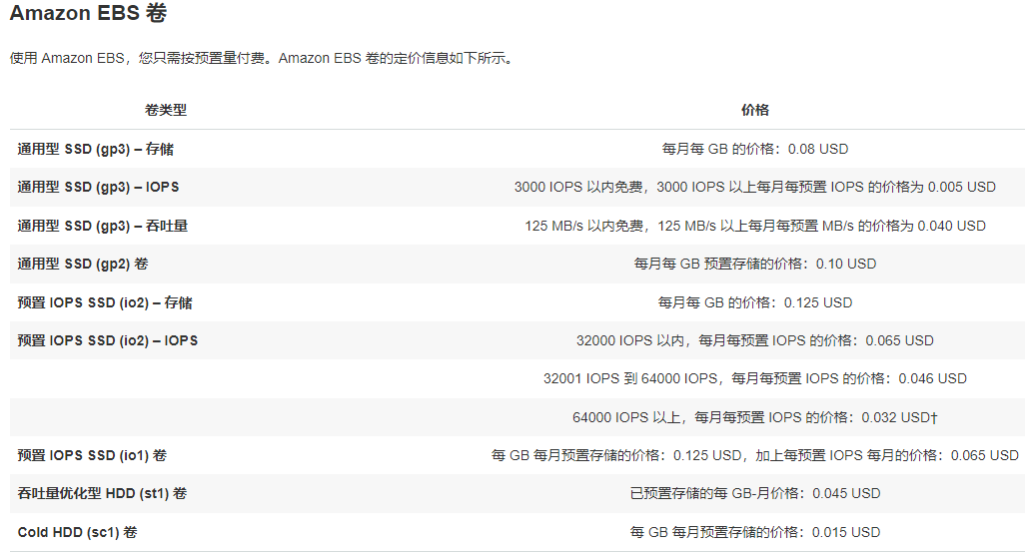

<https://aws.amazon.com/cn/ebs/pricing/>

**AWS gp3卷性能测试样例**

fio --randrepeat=1 --ioengine=libaio --direct=1 --gtod_reduce=1 --name=fiotest --filename=testfio --bs=4k --iodepth=64 --size=8G --readwrite=randread

fiotest: (g=0): rw=randread, bs=(R) 4096B-4096B, (W) 4096B-4096B, (T) 4096B-4096B, ioengine=libaio, iodepth=64  
fio-3.28  
Starting 1 process  
  
fiotest: (groupid=0, jobs=1): err= 0: pid=600: Mon Nov 6 03:03:36 2023  
 read: IOPS=2560, BW=10.0MiB/s (10.5MB/s)(8192MiB/819016msec)  
 bw ( KiB/s): min= 5200, max=14136, per=100.00%, avg=10247.15, stdev=2735.47, samples=1637  
 iops : min= 1300, max= 3534, avg=2561.75, stdev=683.85, samples=1637  
 cpu : usr=0.73%, sys=2.11%, ctx=533990, majf=0, minf=72  
 IO depths : 1=0.1%, 2=0.1%, 4=0.1%, 8=0.1%, 16=0.1%, 32=0.1%, >=64=100.0%  
 submit : 0=0.0%, 4=100.0%, 8=0.0%, 16=0.0%, 32=0.0%, 64=0.0%, >=64=0.0%  
 complete : 0=0.0%, 4=100.0%, 8=0.0%, 16=0.0%, 32=0.0%, 64=0.1%, >=64=0.0%  
 issued rwts: total=2097152,0,0,0 short=0,0,0,0 dropped=0,0,0,0  
 latency : target=0, window=0, percentile=100.00%, depth=64  
  
Run status group 0 (all jobs):  
 READ: bw=10.0MiB/s (10.5MB/s), 10.0MiB/s-10.0MiB/s (10.5MB/s-10.5MB/s), io=8192MiB (8590MB), run=819016-819016msec  
  
Disk stats (read/write):  
 nvme8n1: ios=2456803/20, merge=0/10, ticks=29998042/310, in_queue=29998351, util=100.00%

fio --randrepeat=1 --ioengine=libaio --direct=1 --gtod_reduce=1 --name=fiotest --filename=testfio --bs=8k --iodepth=64 --size=8G --readwrite=randread

fiotest: (g=0): rw=randread, bs=(R) 8192B-8192B, (W) 8192B-8192B, (T) 8192B-8192B, ioengine=libaio, iodepth=64  
fio-3.28  
Starting 1 process  
  
fiotest: (groupid=0, jobs=1): err= 0: pid=639: Mon Nov 6 03:12:03 2023  
 read: IOPS=3008, BW=23.5MiB/s (24.6MB/s)(8192MiB/348531msec)  
 bw ( KiB/s): min=23520, max=71648, per=100.00%, avg=24080.41, stdev=1813.36, samples=696  
 iops : min= 2940, max= 8956, avg=3010.01, stdev=226.67, samples=696  
 cpu : usr=0.80%, sys=2.66%, ctx=260962, majf=0, minf=135  
 IO depths : 1=0.1%, 2=0.1%, 4=0.1%, 8=0.1%, 16=0.1%, 32=0.1%, >=64=100.0%  
 submit : 0=0.0%, 4=100.0%, 8=0.0%, 16=0.0%, 32=0.0%, 64=0.0%, >=64=0.0%  
 complete : 0=0.0%, 4=100.0%, 8=0.0%, 16=0.0%, 32=0.0%, 64=0.1%, >=64=0.0%  
 issued rwts: total=1048576,0,0,0 short=0,0,0,0 dropped=0,0,0,0  
 latency : target=0, window=0, percentile=100.00%, depth=64  
  
Run status group 0 (all jobs):  
 READ: bw=23.5MiB/s (24.6MB/s), 23.5MiB/s-23.5MiB/s (24.6MB/s-24.6MB/s), io=8192MiB (8590MB), run=348531-348531msec  
  
Disk stats (read/write):  
 nvme8n1: ios=1048363/10, merge=0/6, ticks=11435255/138, in_queue=11435394, util=100.00%